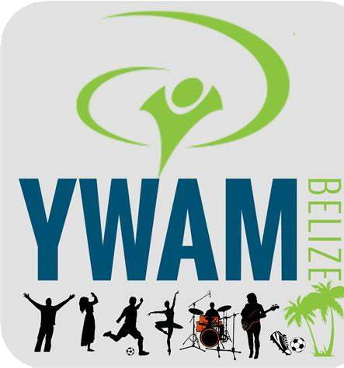

YWAM BELIZE

DTS Application Form

**Personal Information**

|  |  |  |  |  |  |  |
| --- | --- | --- | --- | --- | --- | --- |
| Full Name: |  |  |  |  |  | Nationality: |
| Address: | | | | | | |
| Phone: | | Email: | | | Birthday: | |
| Gender  Marital Status | Female  Single | Male  In a relationship |  | Married |  |  |

|  |  |  |  |  |  |  |  |
| --- | --- | --- | --- | --- | --- | --- | --- |
| Facebook and Instagram Profile (if applicable): | | | | | | |  |
| What languages do you speak? | | | | | | How did you hear about YWAM Belize? | |
|  | | | | | | | |
| Do you have a passport? |  | Yes |  | No | Note: If you do not currently have a passport, please apply for one immediately. It is required and it takes some time to process. | | |

Please share with us a little about yourself. (hobbies, talent, and skills)

Please share with us about your current relationship with Jesus.

What areas of your character are you personally seeking God to further develop or improve?



What are your personal reasons for doing a DTS? (your expectations, motivations, and outcomes you are looking for)

Do you currently or have you ever had any kind of addiction? (pornography, video games, cell phone, tobacco, etc.):

Have you ever worked with YWAM or been on a mission’s trips?

Yes No

If yes, please explain the experience.

Is there anything else you would like to add.

**Emergency Contact**

|  |  |  |  |
| --- | --- | --- | --- |
| Full Name | | | Relationship to you |
| Address | | | |
| Telephone | Mobile phone | Email | |

Additional comments, concerns and or questions:

Kindly email digitally completed forms directly to the school email address: [ywambbdts@gmail.com](mailto:ywambbdts@gmail.com)